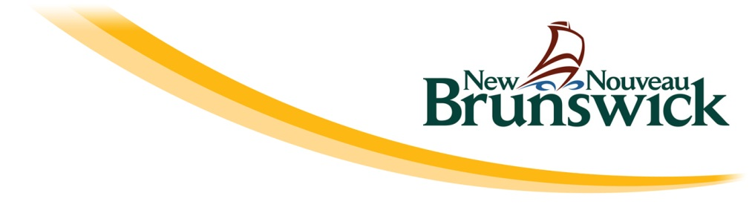

Appendix B – Athlete Development Pathway

An Athlete Development Pathway describes the journey designed for an athlete to provide for optimal development in their sport. It describes the entry point for athletes, the appropriate programs and services at each stage of development, the coaching and officiating that they should be exposed to, the daily training environment, the competitions and active for life opportunities.

The pathway for New Brunswick athletes should align with that established by the national sport organization (NSO) for that sport as laid out in its long term athlete development model, competition system review, athlete development matrix and other related technical documents. The pathway for NB athletes must then take into account New Brunswick’s reality in terms of geography and demographics. For example, what are the competitions that NB athletes should participate in to meet the recommendations for optimal development. And, if the existing competition calendar does not meet this need, what can the provincial sport organization (PSO) do close the gap.

Athletes with a Disability add another layer to the pathway. Athletes with a disability are defined as those who participate in para-sport or Special Olympic events and their participation through the system should also be planned.

The Pathway is broken down into the following sections:

- Strong Technical Leadership and Decision Making
Who plays the leadership role for technical development within your sport? Does your PSO have a written athlete development plan? Is the program well managed and evaluated?

- Athlete Recruitment and Retention
How are athletes recruited into your sport and what is done do to retain them?

- Coach and Officials Development
What is your PSO’s plan to develop the coaching necessary to support the development of athlete through your system from the grass roots to your provincial teams? What is the plan to ensure that your sport has the officials necessary to support the athletes in competitions?

- Programs and Support Services
What programming is taking place at the club and provincial level and does it align with that recommended by your NSO? Are support services (e.g. sport psychology, strength training, nutrition) in place for athletes who require it?

- Daily Training Environment
Do athletes get the right amount of training, led by an appropriately certified coach, using suitable equipment in facilities that meet their needs? Most LTAD models outline the recommended season length, practice session time and days a week that athletes should be committing at each stage of development.

- Provincial Team Program
Does the provincial team program promote athlete development? Does it compliment what is happening at the club level and is it coordinated with club/school programming? What is the role of the Canada Games within your PSO’s provincial team programming?

- The System of Competition
How is the system of competition designed to support the development of athletes from the local level to your provincial team programs? How are clubs modifying competitions for younger athletes? How has your PSO planned the schedule to meet developmental needs? Does your PSO have policies in place to maximise meaningful (close and relevant) competition?

- Working Together
What is your PSO’s relationship with partners in the system such as your NSO, Coach NB, the Canadian Sport centre Atlantic, the NB Interscholastic Athletic Association, Municipal Recreation Programs, NB Wheelchair Sports, etc?

