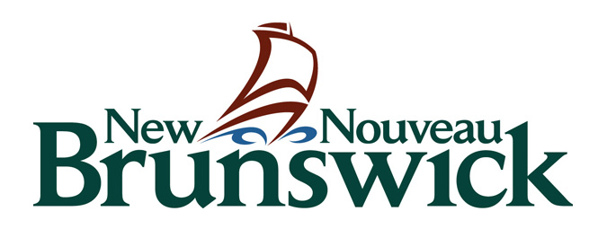
CORE SUPPORT PROGRAM
Community Cultural Centers
Part One

Department of Tourism, Heritage and Culture

Core Support Program Category A
MEDIUM & LARGE COMMUNITY CULTURAL CENTRES

2022-2025
MULTI-YEAR APPLICATION FORM – PART 1
Application Deadline: March 7th, 2022

All organizations should read the guidelines to ensure eligibility and complete Parts 2-4 of the application.

Please ‘save as’ and submit this form electronically labelled as follows:
CoreC-A.1 Form [Name of Organization]

Part One: Applicant Information

 | Registered Name of Arts Organization:
 | Contact person:
 | Title of contact person:
 | Telephone: | Fax: | Email:
 | Address (head office): |  | Postal Code:

Grant Request Amount
Your organization must register with CADAC as soon as possible to avoid delays in providing the financial and statistical information. The CADAC ID code will be provided when you register on-line. See program guidelines for more information.

CADAC ID Code: ___________________

Amount of grant requested (line 4475 of the CADAC financial form): $__________________ annually.

Given the start of a new funding cycle and the context of the global pandemic, the Department is advising core clients to request the actual operating funding amount needed, including operational cost for all recurring projects. This does not guarantee grant amounts will increase, but it will provide the Department and jurors with an accurate picture of the state of the sector.

Please note: The Department accesses your CADAC forms on-line.
Do not attach copies of CADAC printouts with your application.

Agreement and Acknowledgement
- I agree to provide all and only the requested information as well as any other supporting documents needed to evaluate this application. I understand that my application will be refused if it is incomplete. Only the requested information will be reviewed by the jury.
- I recognize that approved support is subject to available funds and that beyond the provision of a grant (if awarded), the Province of New Brunswick has no further commitment to the applicant. The Province will not be held responsible for the completion of an activity.

- I agree to acknowledge the contribution of the Government of New Brunswick in all publicity related to our activities.

- I agree to invite a Program Officer or their supervisor to our organization’s productions or presentations to enable them to have a first-hand understanding of our programming and services, and to provide complimentary admission when feasible.

- I certify that this funding request and the budget submitted with this application have been approved by our Board or our Executive.
- I certify that I have signing authority for the above-named organization and that, to the best of my knowledge, the information provided with this application is accurate. I agree to provide the Department with a full report of the completed activities, including financial statements.
- I understand that electronic submission of this form constitutes my signature.
Name: | Signature: | Title:
Date:

