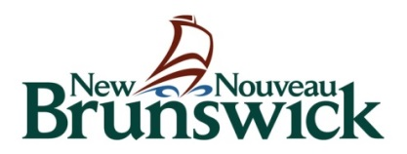

Department of Tourism, Heritage and Culture

CORE SUPPORT PROGRAM
Core Support Program Components “A, B, & C”
Production & Presentation/Service /Community Cultural Organizations

multi-year program
2018-19 FINAL REPORT Guidelines
Annual Reporting Requirements
Organizations that received operational funding as part of a three-year multi-year program for 2016-17 / 2017-18 / 2018-19 are required to provide a grant report prior to the submission of a new application for the 2019-2022 multi-year cycle (Deadline April 26, 2019).

All Applicants
The annual report is to include the following:
- A cover letter that summarizes the report (1 page maximum);
- Completed financial and statistical reports for the 2017-2018 year on the CADAC website https://www.thecadac.ca/login.aspx;
- Audited 2017-2018 financial statement or statement signed by the Board on the CADAC website;
- An updated program list for the year 2018-2019;
- A brief report (2 pages maximum) describing major accomplishments of the 2018-2019 year and a short narrative describing challenges or opportunities.

Note: In the case of disagreement concerning the interpretation of its policies and programs, the Department reserves the right to final interpretation of the intent and implementation of a program. The Department reserves the right to revise programs at any time without notice.

Note: The Department may revise program guidelines or modify the maximum grant amounts without notice based on availability of funds.

Electronic Submision Process
- Final reports must be sent electronically by:
  - Email to culture@gnb.ca (multiple emails if required) or
  - A download link via Dropbox.

Note: The government’s email system has a limit of 9-10MB for any attachments. Anything larger will not be delivered. Our email system will automatically send you an acknowledgement of receipt but that should not be interpreted as all of the information/attachments having been received. When in doubt, please contact our Administrative Assistant at (506) 453-8065.

Contact Information

For questions or assistance, please contact Program Officers, Arts and Cultural Industries Branch
Dept. of Tourism, Heritage and Culture.

Email: culture@gnb.ca
Phone: (506) 453-8065
Website: www.gnb.ca/culture

