Inject # (EXCON use only) | Date | Time inject to be delivered | From (example: Fire Chief) | To (example: EOC)
 | 23 Oct | 1400hrs | EXCON- Woodstock Fire Dept | REMC 12 – Peter K
Inject method (email/phone/TMR etc.) and include actual email or phone # |  | Trusted Agent name and contact information |  | Who will deliver inject (EXCON or Trusted Agent/Other
Email |  | Pete Gallant 292 0678 |  | EXCON
Detailed information
FOR EXERCISE ***** FOR EXERCISE ***** FOR EXERCISE

Who: From: Woodstock Fire Dept.
To: REMC 12 – Peter Kavanagh

What: Major vehicle accident requiring Medivac

When: 23 Oct, 1400hrs

Where: TCH NB2 West at NB Trail overpass in/near Flemington

Details: At 1400hrs, a MVA occurred 2x Transport trucks and a SUV on TCH 2 West on the trail overpass near Flemington (see below map). ANB onsite and have requested medivac of 1x injured. No hazardous material spilled but overpass has structural damage and is closed. Request SNC Lavelin engineers onsite to evaluate.

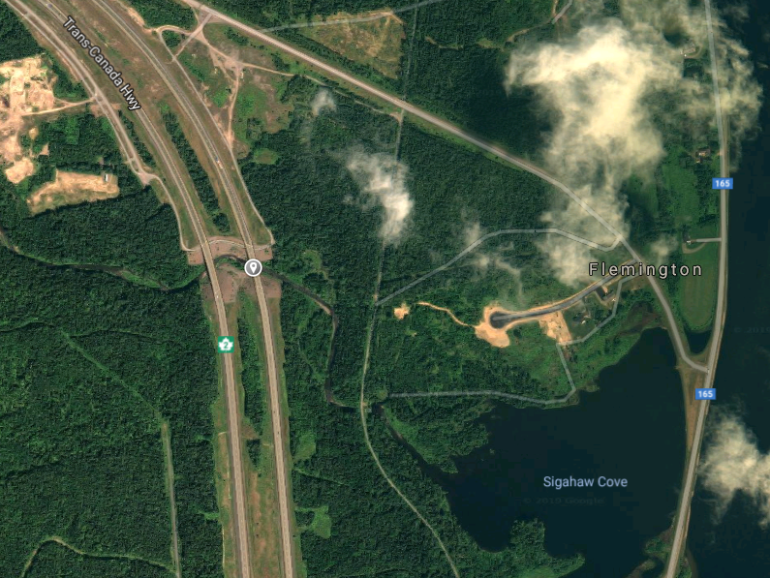

FOR EXERCISE ***** FOR EXERCISE ***** FOR EXERCISE
Instructions – Details on who will deliver this inject (i.e. EXCON acting as Fire Chief will call…..)
EXCON emails REMC 12 with MVA details and impact overpass.

Expected action by Blue Player – The organization/person(s) receiving the inject should do what
REMC should consult REOC and DTI. Inform EMO of situation and TCH closure. Confirm with ANB if medivac possible and alternatives if not.

