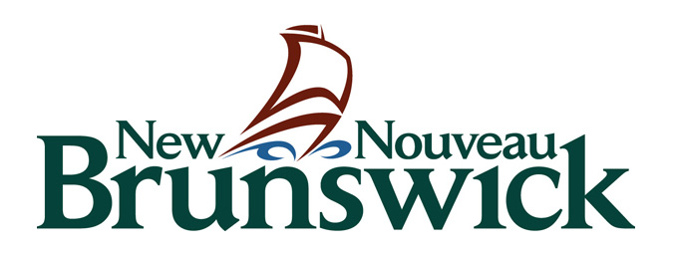
Core C
Community Cultural Centers
Part One

Department of Tourism, Heritage and Culture

Core Support Program Category “C”
Community Cultural Centres

2019-2022
MULTI-YEAR APPLICATION FORM – PART 1
Application Deadline: April 26, 2019

All organizations should read the guidelines to ensure eligibility and complete Parts 2-4 of the application form.

Part One: Applicant Information

Please ‘save as’ and submit this form electronically labelled as follows:
CoreC.1 Form [Name of Organization]

 | Registered Name of Arts Organization:
 | Contact person:
 | Title of contact person:
 | Telephone: | Fax: | Email:
 | Address (head office): |  | Postal Code:

Grant Request Amount
The organization must register with CADAC as soon as possible to avoid delays in providing the financial and statistical information. The CADAC IS code will be provided when you register on-line. See program guidelines for more information.

The CADAC ID code will be provided when you register on-line. CADAC ID Code: ___________________

Amount of grant requested (line 4475 of the CADAC financial form): $__________________ annually. Maximum $30,000.

Please note: The Department will access your CADAC forms.
Do not attach copies of CADAC print-outs with your application.

Agreement and Acknowledgement
- I am providing all requested information in Parts 1 - 4. I understand that my application will be refused if it is incomplete.

- I recognize that approved support is subject to available funds, and that beyond the provision of a grant, (if awarded), the Province of New Brunswick has no further commitment to the applicant. The Province will not be held responsible for the completion of an activity.

- I agree to acknowledge the contribution of the Government of New Brunswick in all publicity related to our activities.

- I agree to invite the Program Officer or their supervisor to all of the organization’s productions or presentations, and to provide them with free admission.

- I certify that this funding request and the budget submitted with this application have been approved by the Board or by its Executive.

- I certify that I have signing authority for the above-named organization and that, to the best of my knowledge, the information provided with this application (Parts 1 – 4) is complete and accurate. I agree to provide the Department with a full report of the completed activities, including financial statements.

- I understand and accept that only the information stipulated in the application requirements Parts 1 – 4 (including Addenda 1 – 6) will be reviewed by jurors and Departmental staff.

- My electronic submission of this form constitutes my signature.
Name: | Signature: | Title:
Date:

